**\*PanTompkins.pdf\***

🡪Computer interpretation of the 12-lead ECG is a popular technique.

🡪Software QRS detectors typically include one or more of

three different types of processing steps: linear digital filtering,

nonlinear transformation, and decision rule algorithms . We

use all three types. Linear processes include a bandpass filter, a derivative, and a moving window integrator. The nonlinear transformation that we use is signal amplitude squaring. Adaptive thresholds and T-wave discrimination techniques pro-vide part of the decision rule algorithm.

🡪QRS detection ::: To achieve reliable performance, we must extract other parameters from the signal such as amplitude, width, and QRS energy .

🡪 It is very important to evaluate a QRS detector algorithm using a standard arrhythmia database. There are now two such databases available: MIT/BIH and AHA (American Heart Association) .

🡪 Fig. 1 shows signals at various steps in digital signal processing.

First, in order to attenuate noise,1) the signal passes through a digital bandpass filter composed of cascaded high-pass and low-

pass filters. Fig. l(b) shows the output of this filter. The next

process after filtering is 2) differentiation [see Fig. 1(c)] , followed by 3) squaring [see Fig. 1 (d)], and then 4) moving window integration [see Fig. 1(e)]. Information about the slope of the QRS is obtained in the derivative stage. The squaring process intensifies the slope of the frequency response curve of the derivative and helps restrict false positives caused by T waves .

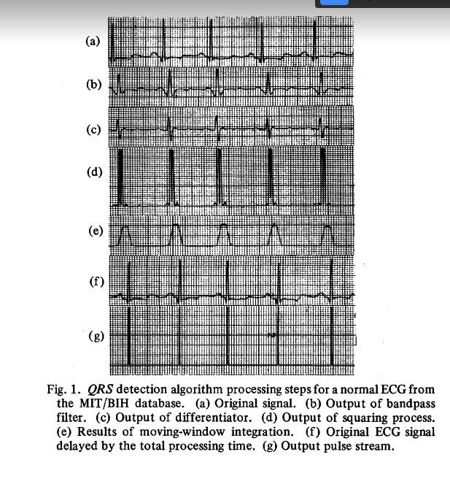

🡪 This algorithm reliably detects QRS complexes using slope, amplitude, and width information. A bandpass filter preprocesses the signal to reduce interference, permitting the use of low- amplitude thresholds in order to get high detection sensitivity.